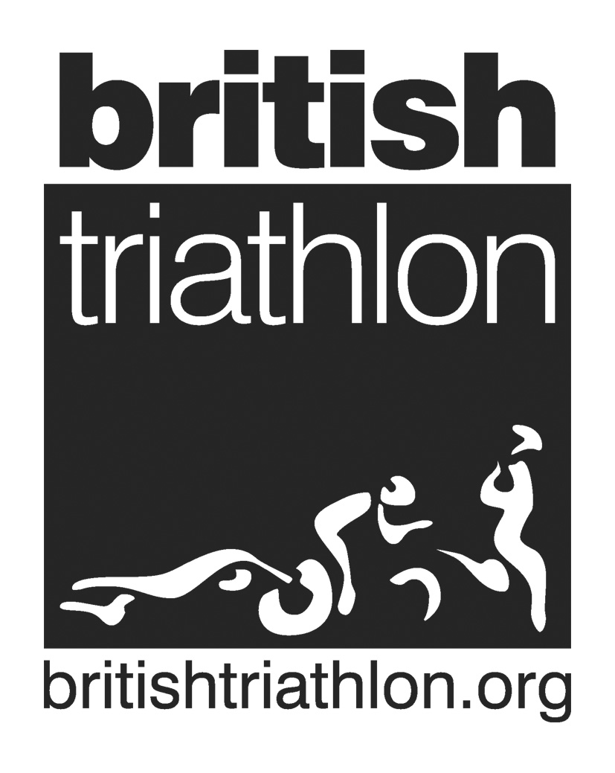
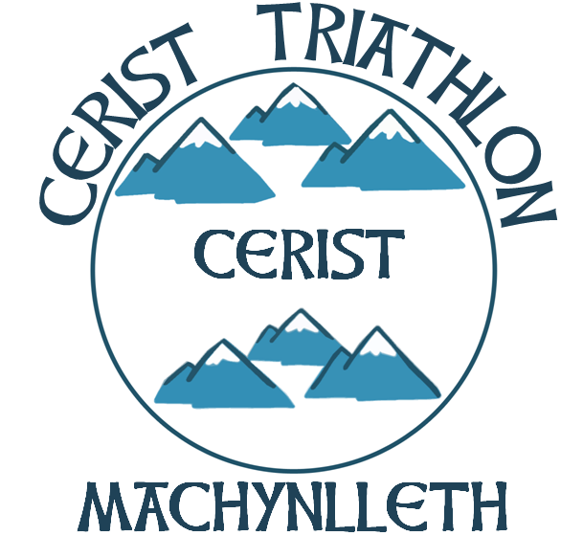
Code of Conduct for Club Members
NAME OF CLUB……Cerist Triathlon…………………………………
Cerist Triathlon Club is fully committed to safeguarding and promoting the wellbeing of all its members. The club believes that it is important that members, coaches, administrators and parents associated with the club should, at all times, show respect and understanding for the safety and welfare of others. Therefore, members are encouraged to be open at all times and to share any concerns or complaints that they may have about any aspect of the club with John Williams – Club Secretary.
As a member of Cerist Triathlon Club you are expected to abide by the following member’s code of conduct:
- All members must play within the rules and respect officials and their decisions.
- All members must respect the rights, dignity and worth of all participants regardless of gender, ability, cultural background or religion.
- Members should keep to agreed timings for training and competitions or inform their coach or team manager if they are going to be late.
- Members must support and encourage good practice and correct actions at all times
- Members must wear suitable kit for training sessions, as agreed with the coach/team manager.
- Members must pay any fees for training or events promptly.
- Members are not allowed to smoke on club premises or whilst representing the club at competitions.
- Members are not allowed to consume alcohol or drugs of any kind on the club premises or whilst representing the club.
- Members are encouraged to communicate with leaders and all other club members

I have read and understood the British Triathlon Code of Conduct for Club/ Event Officials and Volunteers and hereby consent to abide by it.
Name…………………………………. Signed…………………………..
Date…………………………………..

